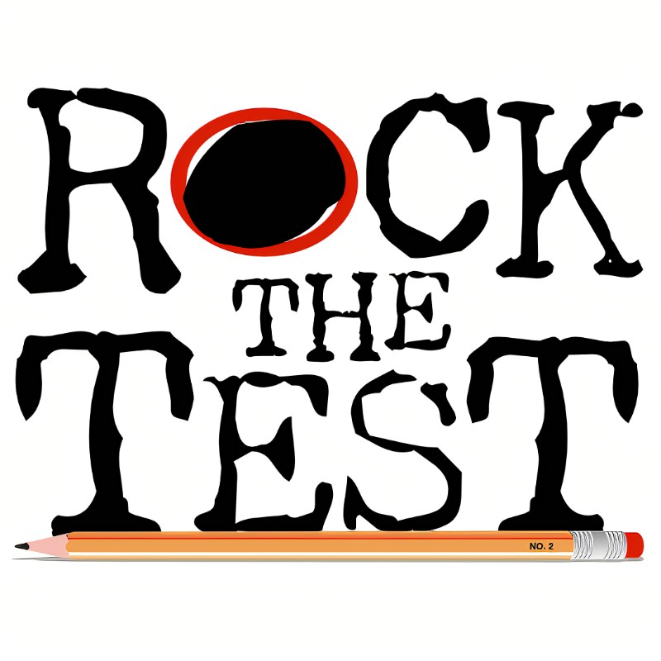

A

ACT Test Prep by Michael Lyons

At St. John’s Coffee House

A three-session workshop:

Oct. 7th, 11th, and 14th

5:00-7:00

$150/ student